Seminar Report Sample
SUO Dingyang 2216110081

Topic 1
The power electronic equipment, which we select in our daily life is a daily necessity desk lamp.
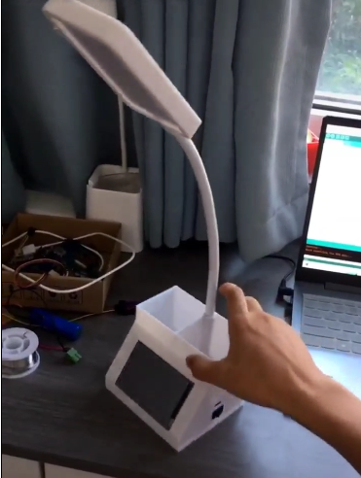
Figure 1: Daily necessity desk lamp
  - Function
This desk lamp combines several advanced power electronics technologies and smart features to provide users with a highly personalized and intelligent lighting experience.
- Touch screen to adjust brightness:
The touch screen of the desk lamp is an advanced brightness control technology. Through capacitive touch sensors and control circuitry, users can easily adjust the brightness of the light, from soft night light mode to bright reading mode, enabling highly personalized lighting needs. PWM (pulse width modulation) technology is used behind the touch screen to control the brightness of the LED lamp by changing the duty cycle of the PWM signal.
- Display time:
This desk lamp also has a time display function, using LCD display. This requires clock circuitry and display control circuitry to track and display time. Power electronics are used here to provide a stable power supply to the clock circuit and to ensure accurate time measurements.
  - Input and output features
- USB 5V power charging interface:
This desk lamp first provides a USB interface for users to charge it. This requires a built-in USB power supply, usually using a switching power supply circuit, to convert the lamp's input power (usually 110V or 220V AC) to 5V DC to meet the standard voltage of USB charging.
- Connect to a wireless network and use your phone to control:
The lamp also has the function of connecting to a wireless network, and the user can remotely display the brightness and time of the console lamp through a smartphone or other smart device. This usually involves a Wi-Fi or Bluetooth communication module and the control circuitry that goes with it. Power electronics are used here to supply power control circuits and communication modules to ensure reliable remote control functions.
- 64 LED lights:
The table lamp uses 64 LED lamps as the light source, which is an efficient and long-life lighting option. These LED lights are usually connected to the circuit board and controlled by the drive circuitry. Each LED may require different currents and voltages, so power electronics is used to design and control the drive circuitry for these LED lights to ensure they work optimally.
  - Configuration of the desk lamp systems
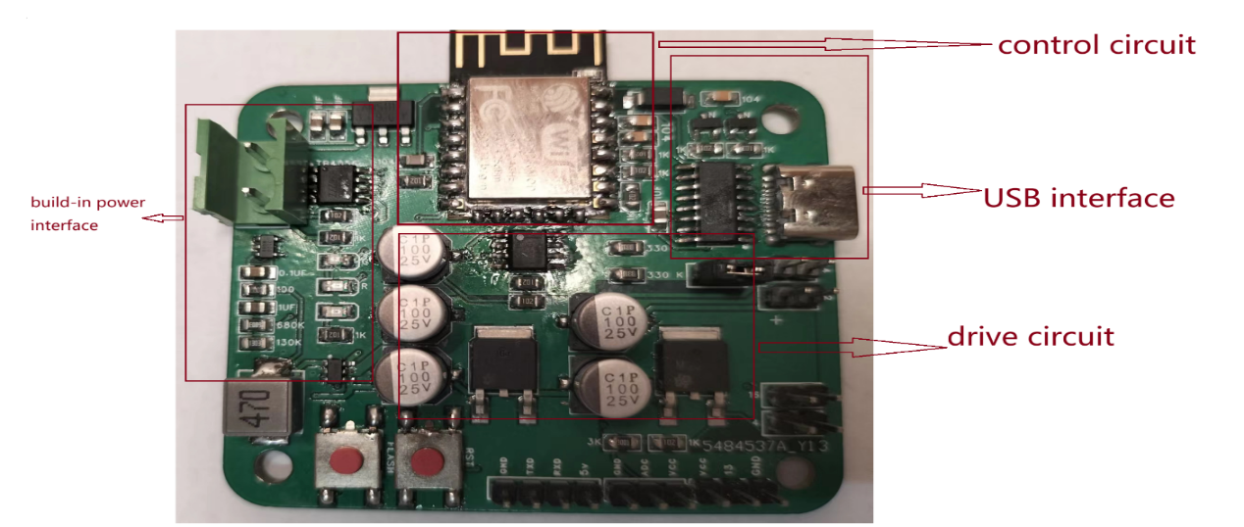
Figure 2:Configuration of the systems
- Power stage
Input Voltage Regulation: The power stage begins by receiving the input voltage from the USB port. In most cases, this input voltage is 5 volts (V), which is the standard USB voltage level. The power stage ensures that the input voltage is stable and within the acceptable range, especially when the USB power source may have voltage variations.
Overcurrent and Overvoltage Protection: The power stage may also include protection mechanisms such as overcurrent and overvoltage protection to safeguard the LEDs and other components from damage in the event of voltage spikes or current surges.
- Control circuit
The control circuit plays a crucial role in the desk lamp, responsible for managing and coordinating various lamp functions, allowing users to achieve brightness adjustment, remote control, and more.
Brightness Control: The control circuit enables users to adjust the lamp's brightness level. This is one of the primary functions of the desk lamp. Typically, this brightness adjustment is achieved through PWM (Pulse Width Modulation) technology, controlling the duty cycle of the LED lights to change the brightness.
Remote Control: The control circuit is closely associated with the desk lamp's remote control feature. Using a microcontroller like the ESP8266MOD, users can remotely control the lamp's power on, power off, and brightness adjustment via a smartphone or other smart devices.
Fault Detection and Protection: The control circuit can also monitor the lamp's operational status, detect faults, and implement protection measures. For example, it can detect issues like overheating, overloading, short circuits, and then shut off the power to prevent damage.
- Drive circuit
Power Management: The driver circuit coordinates the matching of the desk lamp's power voltage with the working voltage requirements of the LED lights. If the desk lamp uses a low-voltage DC power source (e.g., USB 5V), the driver circuit may employ a boost converter to raise the voltage to meet the LED's operational voltage requirements.
PWM Control: To achieve brightness adjustment, the driver circuit typically employs PWM (Pulse Width Modulation) control. PWM control involves altering the LED's duty cycle to adjust brightness. It is an efficient and precise method for achieving a wide range of brightness adjustments.
Reverse Voltage Protection: The driver circuit often includes reverse voltage protection to prevent reverse current from flowing through the LEDs. This protection prevents damage to the LEDs and blocks the flow of current in the reverse direction when the desk lamp is turned off or in the event of a fault.
  - Operating principle

Figure 3:Operating principle
- Role of the Operational Amplifier (Op-Amp):
The operational amplifier is used in the desk lamp for signal processing and amplification. It amplifies the control signal generated by PWM to produce a voltage signal large enough to control LED brightness.
During brightness adjustment, the operational amplifier receives the control signal generated by PWM. The duty cycle of this signal determines the brightness level of the LED. The operational amplifier amplifies this signal to generate the appropriate voltage signal used to control LED current or brightness.
- Role of the NMOS Transistor:
When the voltage signal from the operational amplifier passes through the NMOS transistor, the conduction state of the NMOS transistor is influenced. When the signal voltage is sufficiently high, the NMOS transistor turns on, allowing current to flow through the LED, thereby increasing brightness. Conversely, when the signal voltage is low, the NMOS transistor turns off, blocking current flow through the LED, resulting in reduced brightness.
- Brightness Adjustment Principle:
The principle of brightness adjustment involves altering the duty cycle of the PWM signal to control LED brightness. First, the user selects the desired brightness level through the brightness adjustment feature on the desk lamp or a remote controller. This selection results in an adjustment of the duty cycle of the PWM signal within the control circuit.
After the PWM signal is amplified by the operational amplifier, it generates the appropriate voltage signal. This voltage signal further controls the state of the NMOS transistor. The state of the NMOS transistor, whether it is conducting or not, affects whether current flows through the LED, thereby influencing LED brightness.
By continuously adjusting the duty cycle of the PWM signal, the desk lamp can achieve smooth and precise brightness control, meeting the user's lighting requirements. This principle enables the desk lamp to be efficient, adjustable, and energy-saving, providing an excellent lighting experience.
component used in this equipment
  - Component and model used in this equipment
Device | Model and specification | Function
control chip | ESP8266MOD | generate duty cycle
nMOS | NCE6050KA | switch
amplifier | LM358 | amplify the duty cycle
booster converter | PS7516 | amplify the voltage

Topic 2
Each group will be assigned with a typical fully-controllable power device (MOSFET or IGBT) of certain model. We have established simulation characteristics model of the MOSFET: BSC520N15NS3 There are five characteristics to be specified and their model is established correspondingly.

output characteristics ( I_{D} = f(V_{DS}) under different V_{GS} )
- The simulation model
There are three regions in the out characteristics image, which are the cut-off region, saturation region and the Ohmic region. When the voltage between the gate and the source $V_{GS}<V_{GS}(th)$, called the opening voltage. The drain current $I_{D}$ is cut off, almost approaching to the zero. When $V_{GS}>V_{GS}(th)$ and $V_{DS}>V_{GS}-V_{GS}(th)$, The drain current $I_{D}$ varies linearly with the control voltage $V_{GS}$, and it hardly changes width voltage $V_{DS}$. But if $V_{DS}<V_{GS}-V_{GS}(th)$, The drain current $I_{D}$increases sharply with the increase of $V_{DS}$ the voltage between the drain and the source, called Ohmic region.
- Parameter Setup
Load resistance:$R_{1}=1Ω$
$V_{DC}$: The value ranges from 1V to 150V, with an interval of 0.1V
$V_{GS}$: The value is 4V 5V 5.5V 6V 7V 10V

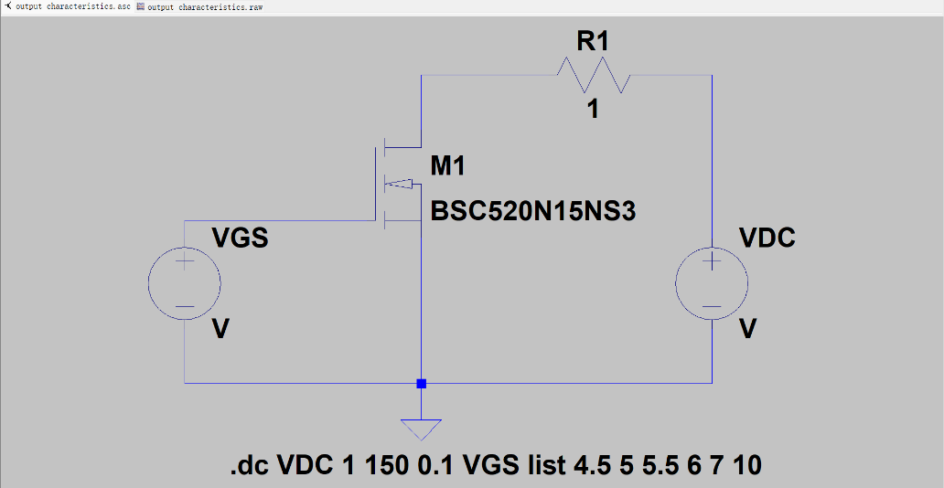
Figure 4: output characteristic schematic
- Simulation results
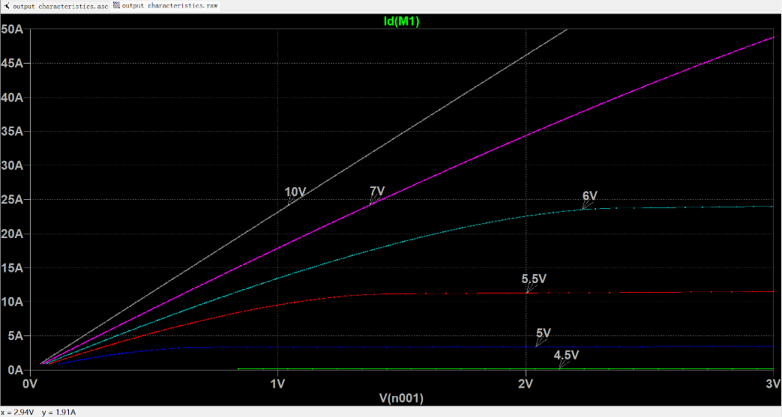
Figure 5: output characteristic waveform
- Analysis of the results
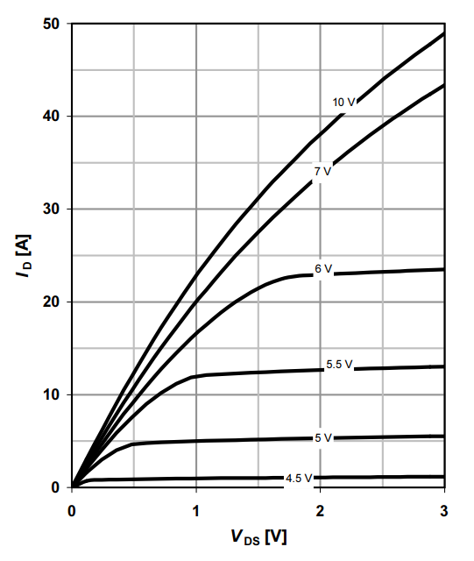

Figure 6: output characteristic waveform given by datasheet
When $V_{GS}=4.5V<V_{GS}(th)$, The drain current $I_{D}$ is cut off, almost approaching to the zero. But when $V_{GS}=5V>V_{GS}(th)$, the MOSFET conduct. If the $V_{DS}$ is very small and lower than $V_{GS}-V_{GS}(th)$, the drain current $I_{D}$increases sharply with the increase of $V_{DS}$ the voltage between the drain and the source. But until $V_{DS}>V_{GS}-V_{GS}(th)$, The drain current $I_{D}$ varies linearly with the control voltage $V_{GS}$, and it hardly changes width voltage $V_{DS}$.
Comparing the images obtained by this simulation with the output characteristic images provided by the data sheet, the change trend of the two is almost the same, and there are certain differences in the specific data.
First, there is a difference between the simulated junction temperature and the actual junction temperature. In the simulation, the MOSFET temperature is set to a constant 25 degrees, and in practice, the MOSFET temperature cannot be constant everywhere.
Second, the value of resistor R1 in the circuit also affects the simulation results. The value in the simulation experiment is 1 ohms, which is equivalent to the wire resistance and measurement deviation in the circuit.

Drain-source on resistance ( R_{DS(on)} = f(I_{D}) under different V_{GS} )
- The simulation model
From the output characteristics, we can know that the drain current $I_{D}$ increases with the decrease of the voltage between drain and source $V_{DS}$. But because $I_{D}$ will approach saturation, and it will arise to a certain value but no charging any more. So the on-state equivalent resistance between the drain and the source R_{DS(on)}$=\frac{V_{DS}}{I_{D}}$ will increase.
And the smaller VGS, the smaller the value of the saturation current $I_{D}$, the faster the resistance becomes larger. Because of that, the higher the gate-to-source voltage (VGS), the smaller the R_{DS(on)}.
- Parameter setup
Load resistance:$R_{1}=0.001Ω$
$V_{DC}$: The value ranges from 0.005V to 150V, with an interval of 0.005V
$V_{GS}$: The value is 5V 5.5V 6V 8V 10V
Temperature: temp 25°C
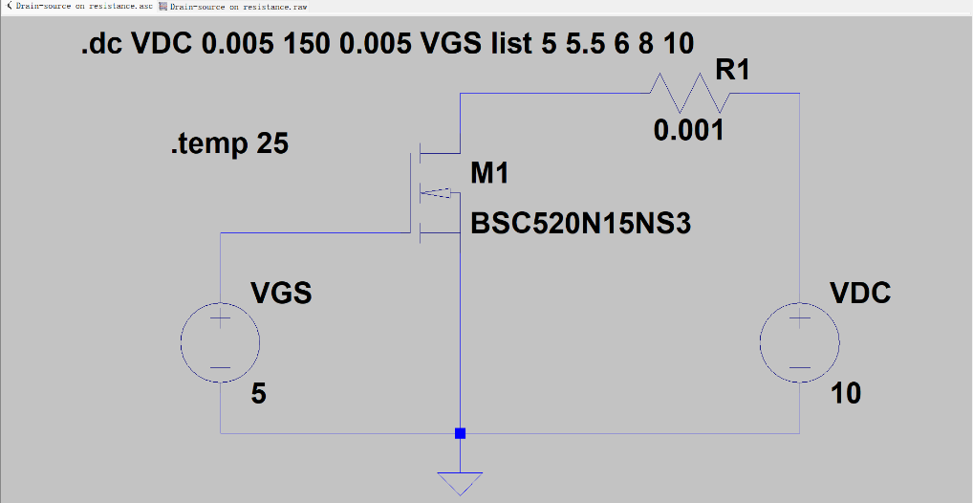
Figure 7: Drain-source on- resistance schematic

- Simulation results
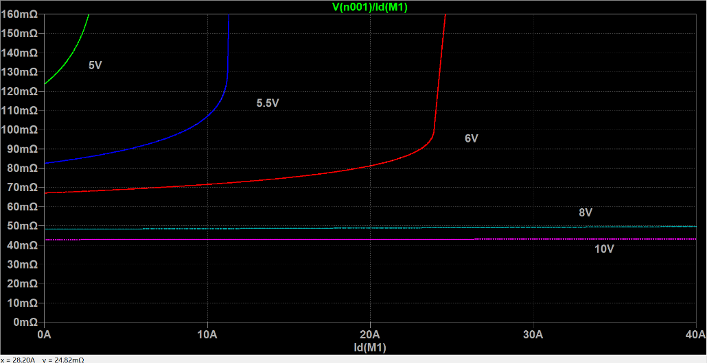
Figure 8: Drain-source on- resistance waveform
- Analysis of results
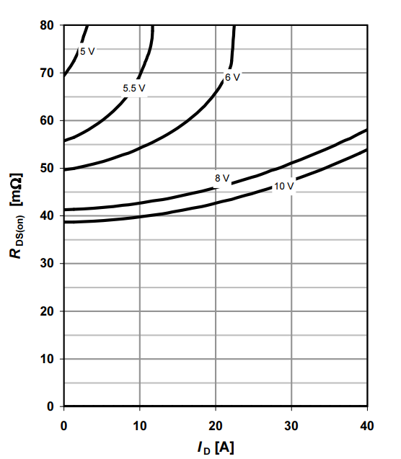
Figure 9: Drain-source on- resistance waveform given by datasheet
All the curves in the figure above, as the drain current is higher, the equivalent resistance is larger, and when the voltage between the gate and the source $V_{GS}$is smaller, the equivalent resistance R_{DS(on)} rises faster.
The smaller VGS, the smaller the value of the saturation current $I_{D}$, the faster the resistance becomes larger. Because of that, the higher the gate-to-source voltage ($V_{GS}$), the smaller the R_{DS(on)}. So as the $V_{GS}$ goes down, the curve goes up.
Comparing the images obtained by this simulation with the Drain-source on- resistance images provided by the data sheet, the change trend of the two is almost the same, and there are certain differences in the specific data.
First, there is a difference between the simulated junction temperature and the actual junction temperature. In the simulation, the MOSFET temperature is set to a constant 25 degrees, and in practice, the MOSFET temperature cannot be constant everywhere.
Second, the value of resistor R1 in the circuit also affects the simulation results. The value in the simulation experiment is 0.001 ohms, which is equivalent to the wire resistance and measurement deviation in the circuit.

Transfer characteristics ( I_{D} = f(V_{GS}) with fixed V_{DS} )
- The simulation model
The relationship between drain current $I_{D}$ and gate source voltage $V_{GS}$ is called the transfer characteristic of MOSFET, when the $I_{D}$ is large enough, the relationship between $I_{D}$ and $V_{GS}$ is approximately linear, and the slope of the curve is defined as transconductance.
From the output characteristics, we can know that when $V_{GS}>V_{GS}(th)$ and $V_{DS}>V_{GS}-V_{GS}(th)$, The drain current $I_{D}$ varies linearly with the control voltage $V_{GS}$, and it hardly changes width voltage $V_{DS}$. This characteristic varies from different temperature, which is caused by the equivalent resistance between the drain and the source and the density of carries in MOSFET
- Parameter setup
Load resistance:$R_{1}=1Ω$
$V_{DC}$: The value is 150V
$V_{GS}$: The value ranges from 0V to 8V, with an interval of 0.01V
Temperature: 25°C 150°C
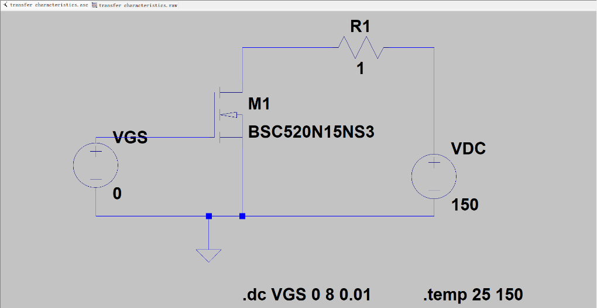
Figure 10:Transfer characteristics schematic
- Simulation results
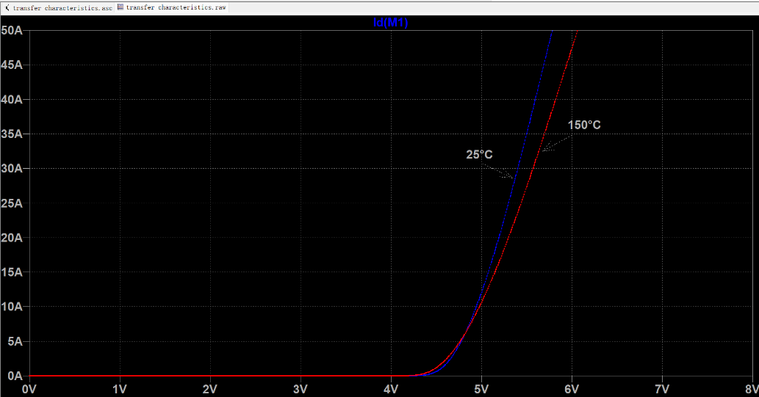
Figure 11: Transfer characteristics waveform
- Analysis of results
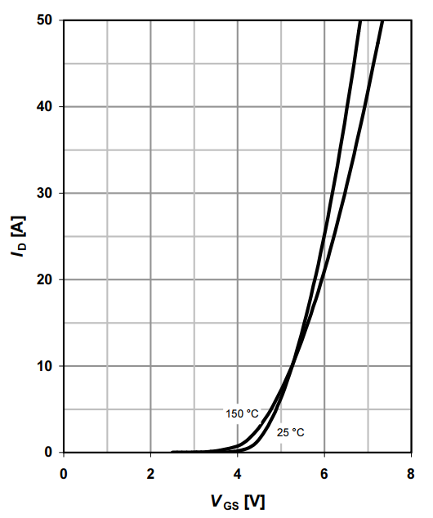
Figure 12: Transfer characteristics waveform given by datasheet
When $V_{GS}$ is larger than the opening voltage $V_{GS}(th)$, the MOSFET tube is turned on, generating drain current $I_{D}$, from the above output characteristics, it can be seen that the larger $V_{GS}$, the larger the $I_{D}$, and at 150 °C, the leakage current is large, because of the larger density of the carriesr; However, due to the increase in temperature, the on-state resistance increases, so when $V_{GS}$ gradually increases, the $I_{D}$ increases faster at 25°C
Comparing the images obtained by this simulation with the Transfer characteristics waveform images provided by the data sheet, the change trend of the two is almost the same, and there are certain differences in the specific data.
First, there is a difference between the simulated junction temperature and the actual junction temperature. In the simulation, the MOSFET temperature is set to a constant 25 and 150 degrees, and in practice, the MOSFET temperature cannot be constant everywhere.
Second, the value of resistor R1 in the circuit also affects the simulation results. The value in the simulation experiment is 1 ohms, which is equivalent to the wire resistance and measurement deviation in the circuit.
Third, different drain-source voltages V_{DS} have different characteristics.

Forward characteristics of reverse diode ( I_{F} = f(V_{SD}) )
- The simulation model
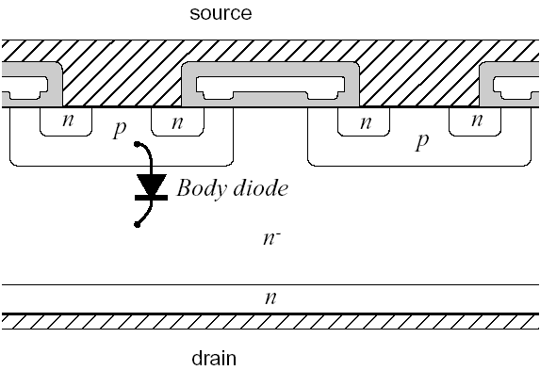
Figure 13: The body diode of the MOSFET
When we apply the reverse voltage between the drain and the source($V_{DS}<0$), as we can seen from the internal structure of the MOSFET, its operating characteristics are equivalent to a diode, because a $p-n^{-}—n$ structure is formed between the source and drain. And the working characteristics of the equivalent diode are related to temperature.
Figure 14: Reverse diode equivalent circuit diagram
- Parameter setup
Load resistance:$R_{1}=0.001Ω$
$V_{DC}$: The value ranges from 0V to 5V, with an interval of 0.01V
$V_{GS}$: The value is 0V
Temperature: 25°C 150°C
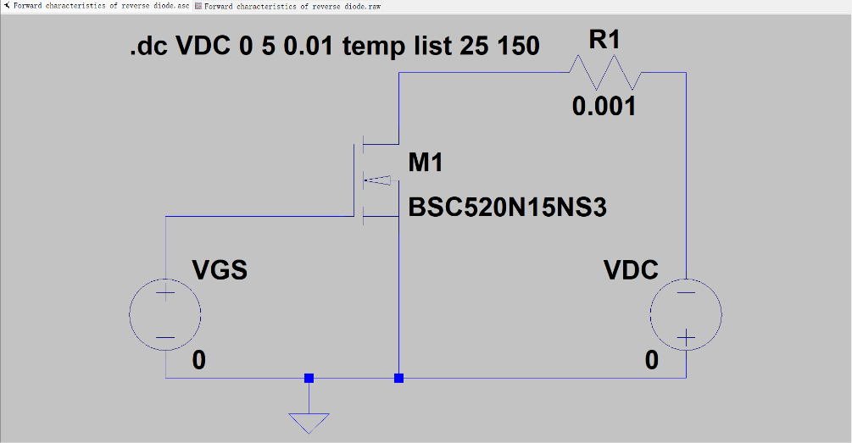
Figure 15: Forward characteristics of reverse diode schematic
- Simulation results
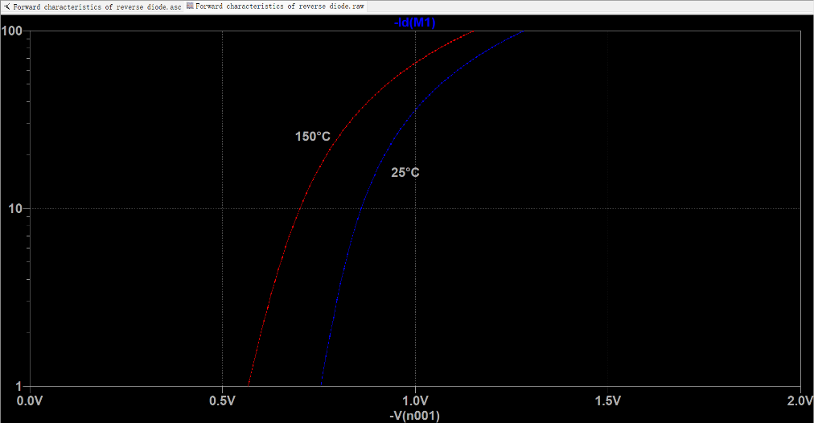
Figure 16: Forward characteristics of reverse diode waveform
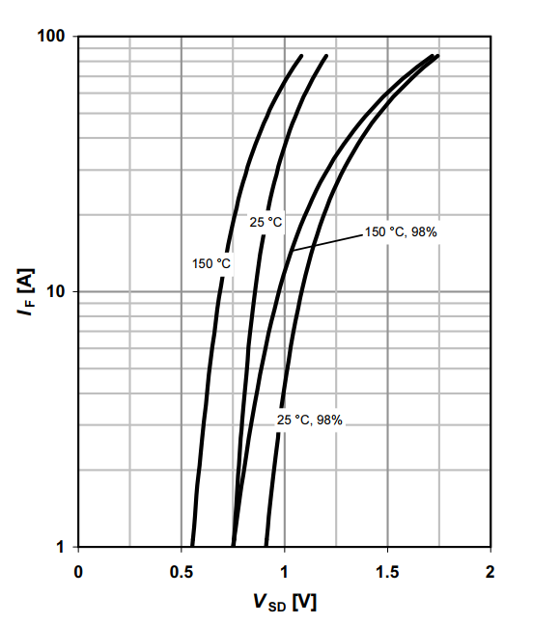
Figure 17: Forward characteristics of reverse diode waveform given by datasheet

As can be seen from the figure, as the temperature rises from 25 degrees to 150 degrees, the characteristic curve shifts to the left. And the reverse voltage is added to the circuit, due to the existence of the body diode, the reverse voltage can be turned on as long as it is greater than the dead voltage of the body diode, which works as a normal diode.
Comparing the images obtained by this simulation with the Transfer characteristics waveform images provided by the data sheet, the change trend of the two is almost the same, and there are certain differences in the specific data.
First, there is a difference between the simulated junction temperature and the actual junction temperature. In the simulation, the MOSFET temperature is set to a constant 25 and 150 degrees, and in practice, the MOSFET temperature cannot be constant everywhere.
Second, the value of resistor R1 in the circuit also affects the simulation results. The value in the simulation experiment is 1 ohms, which is equivalent to the wire resistance and measurement deviation in the circuit.
Third, different gate-source voltages V_{GS} have different characteristics.

Switching waveform
- The simulation model
Figure 18:The equivalent capacitance in MOSFET
Because there is input capacitance $C_{in}$ in the MOSFET, there is a charging process when the pulse voltage arrives, and the drain current $I_{D}$begins to appear when the gate voltage rises to the opening voltage$V_{GS}(th)$.
From blocking to opening the drain voltage drops gradually. In the process of the drain voltage $V_{DS}$dropping, the gate voltage will remain at the value of $V_{GSP}$ and form a platform. It will continue to rise in an exponential curve until the voltage dropping time is over and it will reach its steady state value. The physical process is the signal between the gate and the source charge the capacitance between the gate and the drain (also known as the Miller capacitance). Reverse charging causes the drain voltage, $V_{DS}$, to drop, while the voltage, $V_{GS}$, remains unchanged at $V_{GSP}$.
- Parameter setup
Load resistance:$R_{1}=100Ω$
$V_{DC}$: The value is 100V
$V_{GS}$: A pulse voltage, with a amplitude of 10V, a period of 1$μs$, the duty circle of 1:2
The equivalent resistance between gate and source: $R_{3}=10kΩ$
The internal resistance of $V_{GS}$:100$Ω$
Simulate mode: From time 0, every 10ns, pick a point to know microseconds
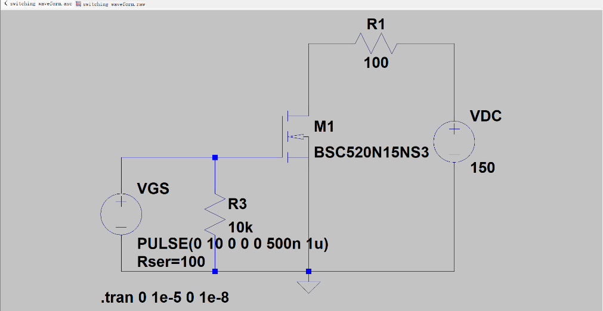
Figure 19: Switching waveform schematic
- Simulation results
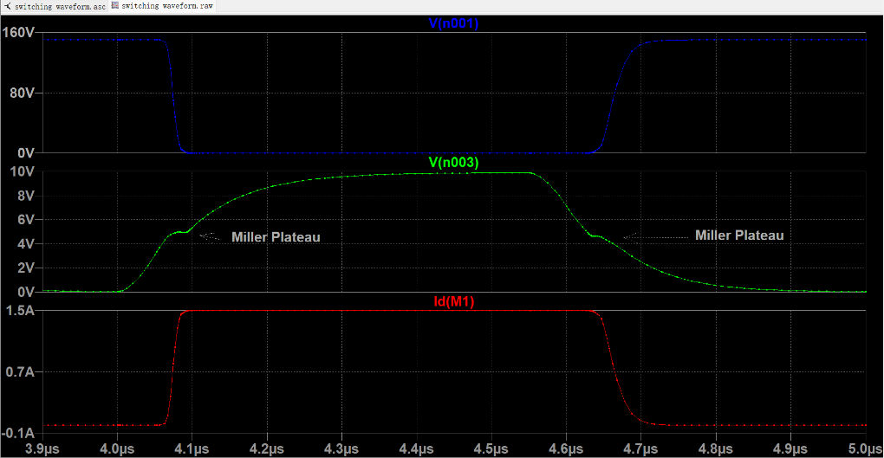
Figure 20: Switching waveform
In the process of the drain voltage $V_{DS}$dropping, the gate voltage will remain at the value of $V_{GSP}$ and form a platform. It will continue to rise in an exponential curve until the voltage dropping time is over and it will reach its steady state value.

Summary
Taking the daily necessities desk lamp as the research object, its input and output characteristics were marked, its internal circuit and working principle were analyzed, and the models, parameters and functional functions of the main power electronic devices and components used in the equipment were queried and summarized.
The power electronics are MOSFET-Infineon-BSC520N15NS3-DS-v02_02-en. LT spice was used to build and simulate the circuit, and the output characteristics, drain-source on-resistance, transfer characteristics, forward characteristics of reverse diodes, and switching waveforms were simulated in different experimental environments, and the simulation data image joint data sheet was analyzed.

